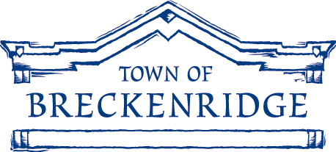

BRECKENRIDGE TOWN COUNCIL

PUBLIC NOTICE

Notice of Special Work Session

Tuesday, October 5, 2010; 12:00 p.m.

County Commissioners Meeting Room

Summit County Courthouse, 208 E. Lincoln Avenue

The Breckenridge Town Council will hold a special joint work session with the Summit County Board of County Commissioners on Tuesday, October 5, 2010, starting at 12 p.m. in the Summit County Courthouse-County Commissioners Meeting Room, 208 E. Lincoln Avenue, Breckenridge, Colorado. The purpose of the work session is to discuss the following item:

PEAK 6 MEMORANDUM OF UNDERSTANDING (MOU)

NOTE: Public hearings are not held during Town Council Work Sessions. The public is invited to attend the Work Session and listen to the Council's discussion. However, the Council is not required to take public comments during Work Sessions. At the discretion of the Council, public comment may be allowed if time permits and, if allowed, public comment may be limited.

_____________________________________________

Mary Jean Loufek, CMC, Town Clerk

Posted at the Breckenridge Post Office and outside the southerly door at Breckenridge Town Hall on September 23, 2010.

